**EEE 148 LTSpice Tutorial Exercise Answer Sheet**

|  |  |  |
| --- | --- | --- |
| **Submitted by**: Emmanuel Estallo | **Student Number**: 2018-02355 | **Section**: HWX |
| **Collaborated with:** | | |

**GENERAL INSTRUCTIONS:** Provide the required information in the spaces provided. If you run out of room for your answer, feel free to adjust the template as necessary.

Instead of attaching a screenshot of your circuit, kindly upload the schematic file instead.

1. (40 pts) **Transient response**. For each circuit below in Figure 1, use a 20Vpp, 1kHz sine wave as an input signal. Then plot 5 full cycles of the input voltage and the output voltage. Use diode = 1N4148, R = 1kohms, C = 1uF.

|  |
| --- |
| **Circuit #1**    **Circuit #2**    **Circuit #3**    **Circuit #4** |

* 1. What is the forward voltage of the 1N4148 diode? (5 pts each)
* The forward voltage of the 1N4148 diode is around 0.69 – 0.70 volts.
  1. How long are 5 full cycles with respect to the input? (5 pts each)
* Since the frequency is 1kHz, one full cycle is equivalent to $T=\frac{1}{1k}=1ms$. Which gives us $5ms$ for five full cycles.

1. (10 pts) **Circuit characterization.** Based on the transient responses in the previous item, what do you think each circuit does? - All or nothing. 2.5 pts each circuit
   1. Circuit 1: It is a clipper circuit. During the negative half cycles of the input, the output is clipped to the diode forward voltage.
   2. Circuit 2: It is a half wave rectifier. All the negative half cycles are removed.
   3. Circuit 3: It is a clamper circuit. The output shows the shifted input signal. The peak-to-peak voltage is the same, but the DC level is shifted upwards by the value of the amplitude minus the diode forward voltage.
   4. Circuit 4: The circuit is a peak detector. During the positive half cycle, the capacitor is charged up to the positive peak minus the diode forward voltage. At the negative half cycle, no current flows since the diode blocks it. Since the capacitor is sandwiched between the ground and the output terminals, there is no way for the capacitor to discharge.
2. (50 pts) **AC Analysis/Frequency Sweep.** For each circuit below in Figure 2, use an AC source with 1V amplitude. Use the .step directive of LTSpice to answer the following:
   1. In the CR circuit, find the value of C that will give a cutoff frequency closest to 3.193KHz (Hint: the value is between 10nF and 100nF). Round off to the nearest ten nF. Use R = 1 kOhms. - 20 pts

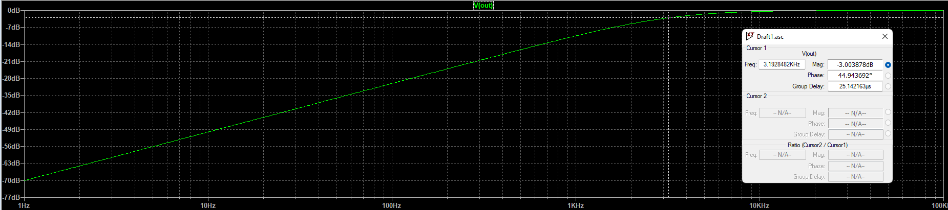

At **c = 50nF**, the cutoff frequency is approximately 3.1928kHz. As we can see from the plot, at frequencies less than 3.19kHz, the gain is attenuated.

* 1. Based on the Frequency plots, what do you call the CR circuit above? - 5 pts
* The circuit above is a high pass filter. Only the components with frequencies higher than 3.19kHz pass through with less attenuation.
  1. In the LR circuit, find the value of L that will give a cutoff frequency closest to 530Hz (Hint: the value is between 10mH and 100mH). Round off to the nearest ten mH. Use R = 100 ohms. - 20 pts

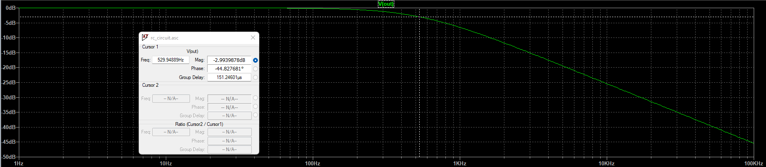

At **l = 30mH**, the cutoff frequency is approximately 530Hz. As we can see from the plot.

* 1. Based on the Frequency plots, what do you call the LR circuit above? - 5 pts
* The LR circuit shown above is a low pass filter. Only the components with frequencies less than 530Hz can pass through with minimal attenuation.